**Experiment 10**

**Student Name: Husanpreet Kaur UID: 20BCS9512**

**Branch: BE-CSE Section/Group: 20BCS-DM-714/A**

**Semester: 6 Subject Code: 20CSP-376**

**Subject Name: Data Mining Lab Date of Performance: 09-05-2023**

1. **Aim/Overview of the practical:** Outlier detection using R programming.
2. **Tools used:** RStudio
3. **Code:**

library(gridExtra)

setwd("C:\\Users\\hp\\Documents\\DATA MINING CODES\\EXPERIMENT 10")

getwd()

data("diamonds")

par(mfrow = c(1, 3))

hist(diamonds$price, main = "Histogram")

boxplot(diamonds$price, main = "Boxplot")

qqnorm(diamonds$price, main = "Normal Q-Q plot")

1. **Output:**

RStudio:

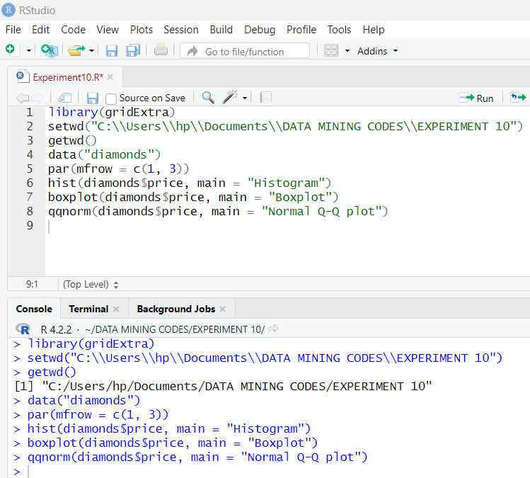

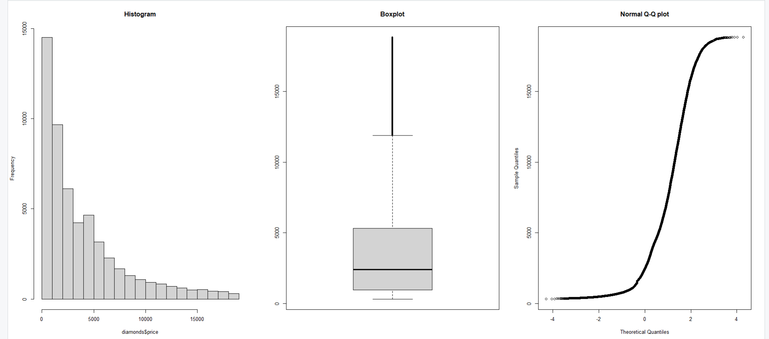

1. **Observation:**

* Learnt how to use R and create a file in Rstudio.
* Learnt how to install packages in Rstudio.
* Learnt how to load dataset diamonds in Rstudio.
* Learnt the use of gridExtra libraries.
* Learnt how to plot data.